2019 BACHELOR OF FINE ARTS GRADUATING EXHIBITION

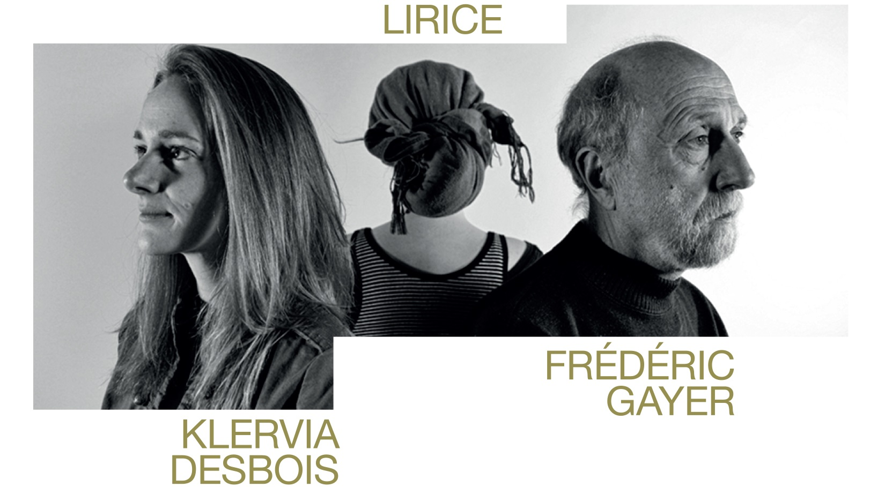

Galerie d’art Louise-et-Reuben-Cohen presents the annual exhibition of works by graduating students of Université de Moncton’s Fine Arts Department. Bringing together the work of Klervia Desbois, Lirice, and Frédéric Gayer, the exhibition proposes paintings, prints and sculptures resulting from themes explored during their studies. The opening will be held on Friday April 12, from 7 to 9 PM, with the artists in attendance.

The pictorial and sculptural work of Klervia Desbois questions the precarity of living beings within the changing, anticipated, even inevitable, ecological crisis. Marks made on matter with blowtorches, candles, acetylene gas, and chemical reactions affirm her concerns for certain marine species of the Atlantic Ocean. Thus, her work reveals a natural space facing the threat of extinction.

Against a backdrop of cultural plurality, Lirice is interested in the mental constructions that are layered onto human rationalities. Through sculpture, she positions her audience in relation to mythical characters in a common space. With printmaking, she illustrates the dualities of perceived reality in a specific context and space. And in her paintings, she erases and reformulates the diverse perspectives of a singular subject. Her work thus strives to make cultural phenomena more comprehensible.

The pictorial interest in Frédéric Gayer’s work lies mainly in societal facts, be it the decay of urban environments or social pressures on our collective unconscious. The narcissism exacerbated by selfies or bodybuilding are striking expressions of this. In a large diptych made in silkscreen, Frédéric attempts, with irony, to break the myth of a single vision of beauty and attempts to remind us that submitting ourselves to the diktats of fashion and consumerism is a form of slavery.

The exhibition will be presented until May 12, 2019. Galerie d’art Louise-et-Reuben-Cohen of l’Université de Moncton is supported by the Canada Council for the Arts and the Department of Tourism, Heritage and Culture of New Brunswick. Opening hours are 1 to 4:30 PM from Tuesday to Friday and 1 to 4 PM on Saturday and Sunday. Admission is free and all are welcome.

