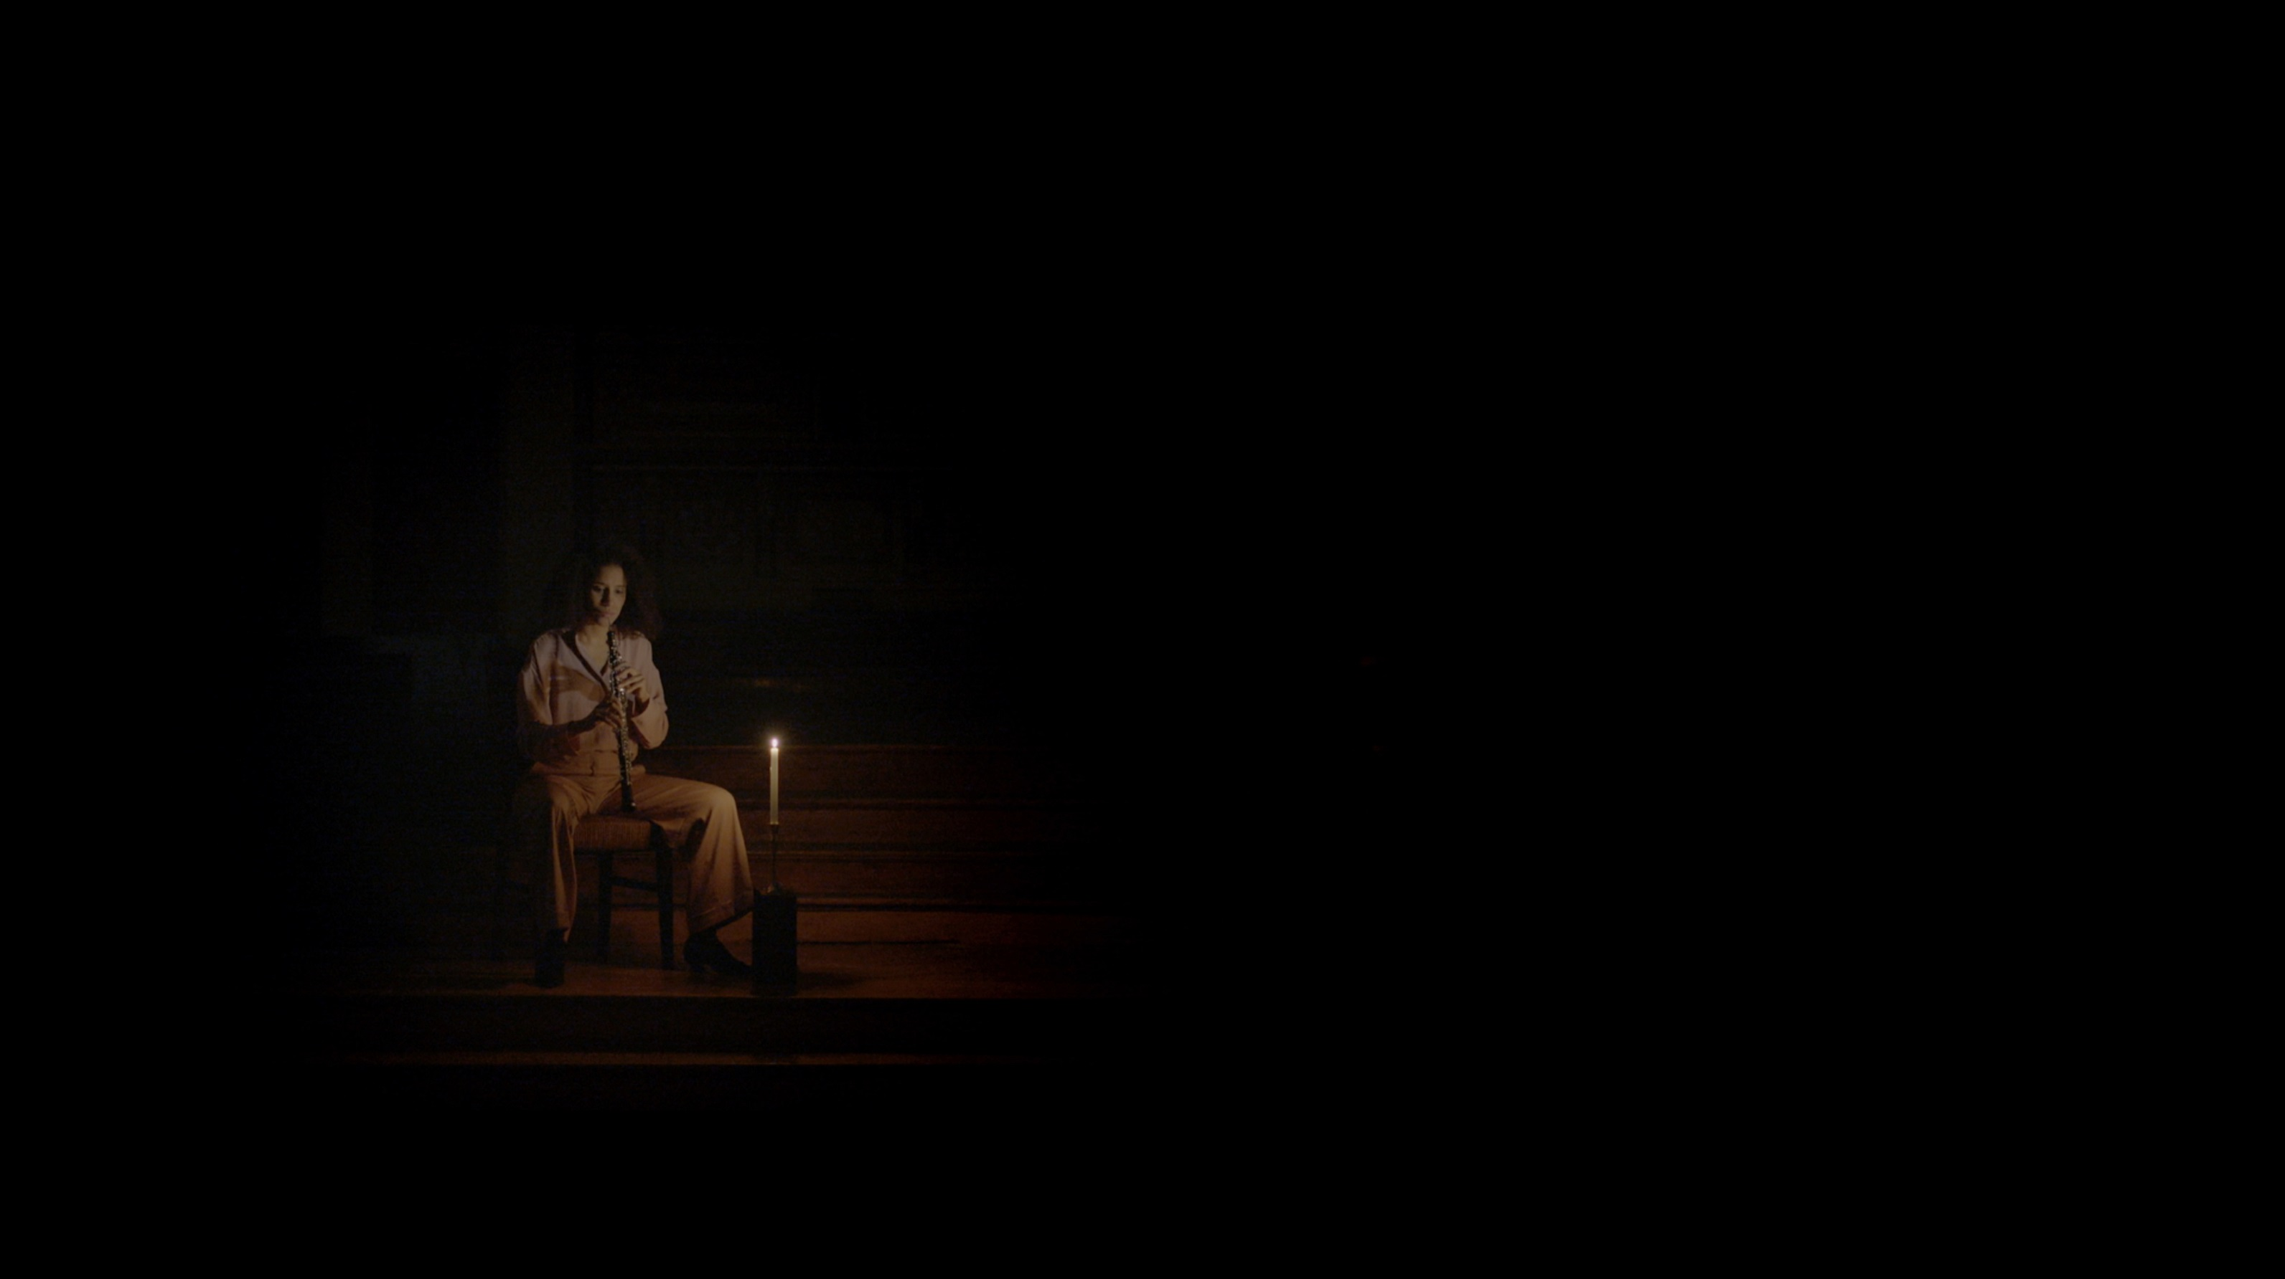
The Withdrawal, 2018
HD video, 53 min.

SCENES AND SEQUENCES BY OLIVIA BOUDREAU

Galerie d’art Louise-et-Reuben-Cohen presents an exhibition titled Scenes and Sequences by artist Olivia Boudreau, curated by Penelope Smart. The opening will be held on Wednesday October 17 at 5 pm, preceded by a commented tour of the exhibition by the artist and curator at 4:30 pm.

Scenes and Sequences is an exhibition that underlines a transition in the work of Olivia Boudreau to more focused experimentations with language, psychology and storytelling. Curator Penelope Smart explains that in these new works: "Boudreau opens her highly-composed filmmaking practice to new visions of sweeping musical performance, words as sculpture and body-as-oracle. [She] turns away from cool detachment towards arresting defenseless intimacy."

The exhibition will be presented from October 17 to December 16, 2018. Admission is free and all are welcome. Gallery hours are Tuesday to Friday, 1 – 4:30 pm; Saturday and Sunday, 1 – 4 pm.

Olivia Boudreau will give an artist-talk (in French) on Wednesday November 21 at noon, at Galerie d’art Louise-et-Reuben-Cohen of Université de Moncton.

The exhibition and artist-talk are presented as part of the Media Arts Section of the International Francophone Film Festival in Acadie 2018 (VAM/FICFA).

